Ivy League’s “Camp Structured”
Before & After Care School Program
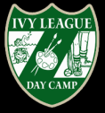

Sign your child up for 2-5 days of Big League Fun during the school year.
Receive quality before and after school care with adult staff and supervision that will actively participate and communicate with your child.

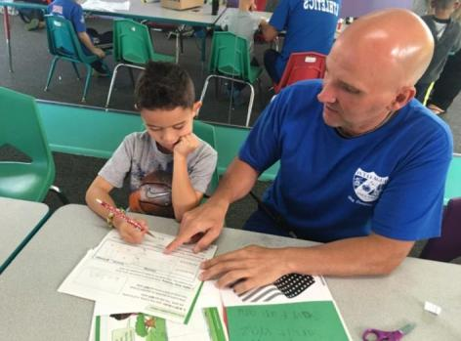
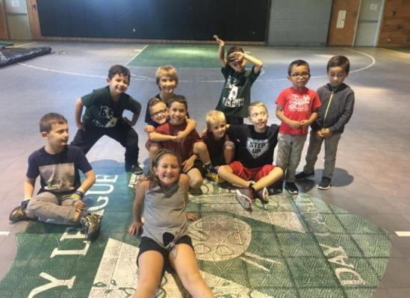

We will provide a structured program in the afternoon including homework help, arts and crafts, sports, special events, snacks, and more. In the morning let your child relax and have a breakfast bunch with friends before the bus come for school.

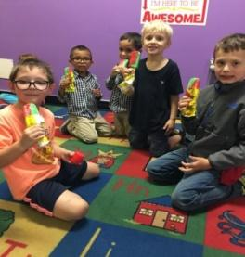

Transportation is provided by Ivy League for Lafayette Mills and Wemrock Book for Aftercare students.

Clark Mills, Milford Brook, Taylor Mills, ELC, and Pine Brook students are transported from and to Ivy League by MERS transportation

Make Ivy League Day Camp your child home away from home before and after school
732-446-7035
140 Gordon’s Corner Road Manalapan, NJ 07726

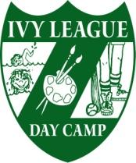

Before and After school Program
Ivy League Day Camp-Before and after school program will open at 6:30 AM for drop off and 7 PM for pick up. Students will be transported by the district to/from your home school. In the Morning students will be welcomed to bring breakfast; snacks may be brought in or purchased for after school program. The afterschool program will have scheduled time for homework, as well as organized games, crafts and performing arts. The program will be facilitated by certified teachers and qualified staff who make children feel comfortable in their surroundings. Young adults and adults are trained prior to the program on the Ivy League philosophy, with each one having the natural ability to connect with children and act as a positive role model. A thorough background check will be conducted on each employee prior to employment. Please see FAQ for more details.

2019-2020 Tuition Schedules

(Minimum of 1 month participation)

Monthly Before School -EARLY BIRD RETURNING RATES (expires July 1)

(Please circle number of days and days of week)

5 Days-$150 4 Days-$135 3 Days-$110 2-Days-$75

Monday Tuesday Wednesday Thursday Friday

Monthly After School Rates

(Please circle number of days and days of week)

5 Days-$300 4 Days-$275 3 Days-$235 2-Days-$180

Monday Tuesday Wednesday Thursday Friday

Siblings will get a 5% discount

10% discount for all Ivy League Campers, Pre-School Students and Pre-K Graduates

Students may participate and be dropped off by parents/guardians on a daily basis for AM $15/$35. A 24 hour notice must be given and approved by the office prior to drop off.

Payment information: Payment for September is due with the application. Payments for each of the following months are due by the 15th of the month prior, last payment for June will be due May
15th. Bills will be mailed the first of the month. Applications can be emailed to
info@ivyleaguedaycamp.com and registration by check mailed to Ivy League Day Camp 140
Gordon’s Corner Rd Manalapan, NJ 07726. Applications must be received by August 21st for participation on the first day of school.

971

Name of Student _ Male Female Birth date

Home Address City State Zip

Home School E-Mail _ @_

Mother’s Name Home Phone

Cell Business Phone

Father’s Name_ Home Phone

Cell Business Phone

Child’s Doctor Address Phone

EMERGENCY INFORMATION: Please list two people, other than parent, who can be contacted in case of an emergency and would be available in case of weather related school closing.

1. Name_ _Relationship Day phone_

2. Name_ _Relationship
Day Phone_

TUITION: TUITION IS FOR THE ENTIRE MONTH, The application needs to be completed and returned to Ivy League by August 17th 2018 with a $35 registration fee. Application fee will be waived if enrolled by June 15th. Payment
for September is due with the application. Payments for the following months are due by the 15th of the month prior;
last payment for June will be due May 15th. No adjustments will be made due to absences. There will be a $30.00 charge for any returned check. Please make your check payable to Ivy League Day Camp.

Ivy League Day Camp reserves the right to accept, to reject any applicant, and to refuse further attendance if, in its sole discretion, it determines that a particular student is not in the best interest of Ivy League Day Camp Ivy League Day Camp reserves the right to charge $20.00 late fee for tuition not received on time. Parent/Guardian gives permission to photograph/video his/her child for the purpose of display on social media.

I agree that any dispute concerning, relating, or referring to this contract, any representation concerning my child’s camping experience, or the camping experience itself shall be resolved exclusively by binding arbitration in NJ, according to the then existing commercial rules of the American Arbitration Association and the substantive laws of NJ. In the event that I, or my family physician, cannot be contacted in an emergency, I hereby grant permission to transport my child to Centra-State Hospital in Freehold to give emergency treatment to my child. I agree to make payments to Ivy League Pre-School according to the program selected.

PARENT or GUARDIAN SIGNATURE Date

Before School/After School FAQ

What is the enrollment and payment process for the program? Applications can be downloaded at the following link http://www.ivyleaguedaycamp.com/Camp/form.php

Applications can also be picked up at our office year round. The application needs to be completed and returned to Ivy League by August 21st 2018 with a $35 registration fee. Application fee will be waived if enrolled by July 1st. Payments for the following months are due by the 15th of the month prior. September payment is due with application; last payment for June will be due May 15th. Applications can be emailed to info@ivyleaguedaycamp.com and registration by check mailed to Ivy League Day Camp 140 Gordon’s Corner Rd Manalapan, NJ 07726.

Who will be facilitating the program and supervising the children?

The program will be facilitated by certified teachers and qualified staff who make children feel comfortable in their surroundings. Young adults and adults are trained prior to the program on the Ivy League philosophy, with each one having the natural ability to connect with children and act as positive role model. A couple background check is completed on each employee.

How will the Ivy League afterschool program differ from other afterschool programs?

The staff will be taking an active participatory role with the children in the program. The staff will be proactively facilitating activities in a structured camp program. Staff will not just be supervising the children but will be actively involved with children with their homework, sports/games, and creative/performing arts programs. Our camp staff understands the quality of care needed to make sure the children enjoy the aftercare program. The program will have a schedule of structured activities and club programs that will be diverse and change monthly. Students will be broken up by age, siblings can be requested to stay together.

Will my child have someone to help with homework?

YES! There will be a set time for homework to be completed. If a child needs help completing or understanding their homework, the staff will help clarify lessons and help them finish their homework assignments. One on one tutoring will also be available to work towards specific goals.

What are the program hours and what about delayed openings/half days/days school is closed?

The program will begin at 6:30 AM and end at 6:30 PM. If Manalapan-Englishtown has a delayed opening the before care program will begin at 8:00 AM. ON half days students will be bused to camp at the end of the half day and have an extended program. Special Event Fun Days programs will be run on days the schools are closed for an additional daily charge.

Can I enroll in program on a daily basis and make changes on number of days and what days of week enrolled in program?

Yes, you can transport your child to the program and pay a daily fee. Applications must be completed before start date. Students may participate and be dropped off by parents/guardians on a daily basis. A
24 hour notice must be given and approved by the office prior to drop off. Changes can be made on a monthly basis. Please communicate any school transportation changes with Manalapan-Englishtown Transportation.

Can I enroll in Ivy League Aftercare Program if Manalapan-Englishtown does not provide transportation to Ivy League for aftercare?

Yes, Ivy League provides transportation in a mini van driven by a CDL driver to Ivy League for aftercare from Lafayette Mills and Wemrock Brook Schools. We do not provide transportation to Lafayette and Wemrock for before care at this time.

