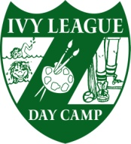
140 Gordon’s Corner Road
Manalapan, New Jersey 07726
Phone: 732-446-7035
Fax: 732- 446-5623
e-mail: info@ivyleaguedaycamp.com

Ivy League Day Camp
Jonathan Leiser, Owner, Director
Evan Leiser, Owner, Director

October 2020

Dear Ivy League Driver,

We are gearing up for next season and would like to know if you are available.

Please return the tear off below to our office by November 1ST.

Camp will be in session from Monday, June 28th thru Friday, August 20th. There is no Camp on Monday, July 5th

This form is not a guarantee of employment for 2021. We hope that you will be with us once again.

Very truly yours,

Jon Leiser
Evan Leiser
Neal Felsen

Please return by November 1, 2020

______________I would like to be considered for a position for 2021

______________I do not want to be considered for a position for 2021

______________I am unsure at this time. Unfortunately, I realize that this delay
may mean my position will be filled.

Name ____________________________________ Date______________
(Please print)

Phone # __________________________

Email ______________________________@ ________________________

