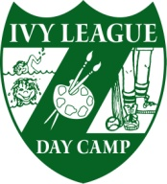
140 Gordon’s Corner Road
Manalapan, New Jersey 07726
Phone: 732-446-7035
Fax: 732- 446-5623
e-mail: info@ivyleaguedaycamp.com

Ivy League Day Camp
Jonathan Leiser, Owner /Director
Evan Leiser, Owner /Director

Returning Staff Form

Please return by November 1, 2020

_____ I would like to be considered for a position.

_____ I am unsure at this time. I realize that this delay may unfortunately mean my position
will be filled.

I would like to be considered for a different position.
____ Yes ____No

If yes, indicate which position. _________________________________________

I would like to recommend for a camp position:

Name

Address

Phone #

Age or school grade

Position, if known

Name __________________________ Date ______________
(please print)

Phone Number ______________________

Email ________________________________@__________________________

